Optimal Size and Joint Operation of Wind Power and CCS Coal Plant with Amine Storage

Abstract ID: 423

Rubenka Bandyopadhyay* and Dalia Patiño-Echeverri¹

Abstract

This paper presents a mixed-integer linear optimization model to find the component sizes and operating schedule that maximize the profitability of a hybrid electric power generation unit, consisting of a new wind farm integrated with an existing coal plant retrofitted with amine-based post-combustion Carbon Capture System (CCS) and amine storage. This hybrid system reduces both the costs of integration of wind power into the grid, and the costs associated with the energy penalty of the CCS. The amine storage system allows storing CO₂-rich amine solution to reduce the energy penalty of the CCS system at times of high electricity prices/high demand. The amine-rich solution can be regenerated at an enhanced rate when electricity prices are relatively low or when wind power output exceeds the transmission capacity of the connector lines. In this way the amine-storage system effectively provides ‘storage’ for wind power. The amount of available wind power is modeled by Markov Chain Monte Carlo (MCMC) method, and provided as input data for the linear optimization model. The analysis is conducted with and without constraints on the maximum hourly variation of dispatched power from this system.

Keywords
Wind Energy, Hybrid System, Carbon Capture & Storage (CCS) (Carbon Capture & Sequestration), Amine Storage, Optimal Operation

1. Introduction

1.1 Background information
Wind power and Carbon Capture & Storage (CCS) are two of the most promising technologies to reduce CO₂ emissions from electricity generation. CCS technology for a coal plant consists of equipment to capture CO₂ either before or after combustion, and sequester it underground so that it does not escape to the atmosphere. Of the different kinds of CCS technology available, the post-combustion amine based CCS system is the best developed and most likely to be used for retrofitting coal plants [1, 2]. In the amine-based post-combustion system, the flue gas from the coal plant is treated with aqueous mono-ethanol amine (MEA) solution (amine sorbent/solution) in a scrubbing system. The scrubbing system is composed of two parts: (a) the absorber, where the CO₂ from the flue gas is absorbed by the MEA solution, and (b) the regenerator, where steam from the coal plant heat cycle is used to regenerate CO₂ from the CO₂ rich amine solution, and recover the original sorbent [2]. Capture of CO₂ by amine solution has been successfully applied to gas and coal fired plants on a small scale [2, 3]. However, the use of steam from the plant’s heat cycle during regeneration of sorbent results in significant loss of efficiency in the generating unit [1]. A review of current literature, suggests a CCS energy penalty range of 20-40 % on the net power output [2, 4]. Approximately 55% of the CCS energy penalty occurs due to sorbent regeneration, and 35% is for compression of captured CO₂ so that it can be transferred to the sequestration site [5].The loss of revenue due to energy penalty from installation of CCS could be reduced by enabling amine storage. Amine storage technology allows the coal plants to utilize price volatility in the electric power market: storing the CO₂ rich amine solution in tanks so that the plant can sell more power during high electricity prices and regenerate and compress CO₂ from the CO₂ rich amine solution at a ramped up rate during low or negative electricity price durations [1,5]. Adding amine storage to post-combustion system allows the CCS system to postpone roughly 92% of its energy consumption, to benefit from electricity price variations without emitting any additional CO₂ to the atmosphere [5].

The loss of revenue due to CCS energy penalty can be further reduced by integrating the unit with an on-site wind farm, and using wind power (whenever available) to compensate for the energy penalty associated with CCS. Stand-alone wind farms are a source of intermittent supply of electricity which affects the reliability and reserve requirements of the power system. If sized optimally, the hybrid system under consideration (coal plant with amine storage CCS integrated with wind power), can be dispatched to maximize profits given electricity prices and wind power conditions. By providing flexibility to reduce or increase the power that flows from the wind farm and coal plant to the grid, the amine-storage system provides a form of ‘storage’ for wind power. Besides, as the new wind farm is to be integrated with the existing coal plant, most of the expenses of connecting the wind farm to the grid are avoided.

1.2 CCS and Wind Power: The potential for combining coal units with CCS, and wind power units in the US
This system could be of significant interest in the U.S. As of January 2013, 29 states, Washington DC and 2 territories in the country have Renewable Portfolio Standards (RPS), while 8 states and 2 territories have RPS goals [6]. A significant portion of this new generation capacity to satisfy the RPS standards could come from wind power which has a vast potential of 10,500 GW at an elevation of 80 meters, and 12,000 GW at an elevation of 100 meters [7]. Given these estimates and comparatively low costs of wind power, it is expected that a number of states may choose to meet RPS goals by developing both local and distant wind resources depending on power transmission capacity and siting constraints [8]. A hybrid system like the one analyzed in this paper would also reduce the variability of the wind power output therefore substantially mitigating the need for adjustments in the overall flexibility of the power system where it operates.

On the other hand, despite increases in electricity generation from renewable sources and natural gas, coal continues to be an important resource in the U.S. energy mix. While this participation decreased in 2012 by roughly 6% (as per calculations done from data available in [9]) due to a combination of reduced demand and unusually low natural gas prices, different factors point to prolonged prominence of this resource in the U.S as indicated by recent projections [9]. The joint influence of stringent air emissions regulations for coal-fired power plants, and low natural gas prices will force the retirement of inefficient plants, it is unlikely that a large number of coal based plants will be retired immediately, particularly considering that efforts to develop and demonstrate carbon sequestration technologies for coal-fired plants continue to be a top priority for the government and industry [10].

2. Contributions of this Paper

The work presented here utilizes a mixed-integer linear optimization model to identify optimum configuration, required price variations, and allowable ranges of capital costs for such a hybrid system. To the best of our knowledge, similar analysis has not been attempted previously. Kang et al [11] modeled a similar hybrid unit with an additional natural gas generator and provided analysis demonstrating the use of optimization techniques for obtaining the most profitable operation schedule, without considering capital costs to first determine the optimal sizes of the component units. Also, different from [11] we look at effects of PTC structure in subsidizing such hybrid systems, and also calculate ranges of allowable capital costs of wind farms and CCS technology for profitable operation of the system.

3. Overview of method

As has been stated previously, the hybrid system consists of an extant coal plant retrofitted with amine-based post-combustion CCS system and amine storage, integrated with a new onsite wind farm. A first step towards building this hybrid system would consist of identifying a coal plant with CCS located in the proximity of an area with potential for wind power development. Once a potential site for a hybrid system is located, it would be necessary to estimate the installed capacity of the new wind farm, and the size of the amine storage system required to maximize investors’ profits. It is assumed that no additional transmission lines are installed to connect the wind farm to the grid and that it uses the existing transmission lines connecting the coal plant to the power grid. The second assumption is valid, since the net power output of the existing coal plant is reduced when the CCS system is operating and therefore, provided the wind farm size is chosen optimally, the power output of the hybrid system (consisting of the coal unit and the wind farm), can use existing transmission lines to inject electricity into the power grid. For the analysis presented in this paper, the time resolution is one hour, to take advantage of hourly input data for available wind power and electricity prices (LMPs). However, if input data is available on a finer scale in time, the model can be easily adjusted to perform optimization accordingly. The linear model maximizes the profits of the system, which depend on estimates of capital costs for the CCS system and the wind farm, operation and maintenance cost of coal plant, forecasts of available wind power and electricity prices (LMPs), and Production Tax Credit for generated electricity from wind power (if available), to obtain optimum installed capacity of wind farm and size of amine storage tank. The capital cost of wind farm depends on${ O}_{W}^{max}$, the installed capacity of the wind farm.

The costs of installing the amine storage system can be broken down into two categories:
(a) The cost of the CO2-rich amine storage tank and the cost of an extra supply of fresh amine. The tank stores the CO₂ rich amine solution that is not regenerated at times of high electricity prices. The supply of extra fresh amine is necessary so that there is a constant provision of unsaturated amine to the capture unit and CO₂ is still absorbed from the flue gas each hour. This cost depends linearly on$H_{S}^{max}$, the maximum number of hours for which the system can continuously store the CO₂ rich amine solution. $H_{S}^{max}$ is a decision variable in the linear optimization model.
(b) The cost of scaling up the components of the CCS system associated with regenerating and compressing CO₂ from the CO₂ rich amine solution. Since regeneration does not occur every hour, the saturated (CO₂ rich) amine solution stored in the tank and the saturated amine solution produced at the current hour must be regenerated simultaneously during certain hours, called the regeneration mode hours. So the regeneration rate and the volume of CO₂ being compressed is greater (during regeneration mode hours) compared to that of a CCS system that performs regeneration and compression continuously at all hours. Thus, the components of the CCS associated with regeneration and compression of CO₂ from the CO₂ rich amine solution, need to be scaled up in size. We define the rate of regeneration of the CO₂ rich amine solution during regeneration mode hours $(Rate_{regenerate})$as $\frac{H_{S}^{max}}{H_{R}^{full}},$where the number of hours required to regenerate the entire volume of saturated amine solution in a full tank is denoted by${ H}_{R}^{full}$, and $H_{S}^{max}$ is as defined in (a). The size of the appropriate components of the CCS system need to be increased by a factor equal to $Rate_{regenerate}$in order to be able to simultaneously regenerate and compress CO₂ from the CO₂ rich amine solution stored in the tank, and the saturated amine solution produced at the current hour. Thus, the final size is given by (1+$Rate_{regenerate})$*(the size of the components of CCS responsible for regeneration and compression of a continuous operation CCS). The overall scaling factor is therefore (1+$Rate_{regenerate})$. For example, if the overall scaling factor is 2, it means that $Rate_{regenerate}$ is 1. So one hour of operation with storage of CO₂ rich amine solution requires one hour of operation in the regeneration mode. Since the scaling factor is 2, the size of the CCS components is doubled, such that during one hour of operation in the regeneration mode, the CCS unit is able to simultaneously regenerate and compress CO₂ from the saturated (CO₂ rich) amine solution stored in the tank for an hour, and the saturated amine solution produced at the current hour. The cost of scaling up components of CCS system is proportional to the overall scaling factor. The overall scaling factor is treated as an input parameter for the optimization problem. Since the overall scaling factor depends upon$\frac{H_{S}^{max}}{ H_{R}^{full}}$, and $H_{S}^{max}$ is a decision variable in the optimization problem, the value of ${ H}_{R}^{full}$ is adjusted such that $\frac{H_{S}^{max}}{H_{R}^{full}}$ remains constant and the scaling factor remains equal to the fixed input value, irrespective of the optimum value of $H_{S}^{max}$, obtained from the linear model. A scaling factor of 1 implies that the CCS system is not equipped with an amine storage tank.

The operation of the CCS system with amine storage is modeled in a way similar to [5]. We assume the CCS with amine storage system has been designed to operate in one of the three modes of operation:
- Storage mode: The CO₂ rich amine solution obtained during CO₂ capture in current time is stored in the amine storage tank. Unsaturated (CO₂ lean) amine solution is passed through the system for CO₂ capture.
- Regeneration mode: The CO₂ rich amine solution contained in the amine storage tank is regenerated simultaneously with CO₂ rich amine solution produced at the current hour, to obtain unsaturated amine solution that can now be passed through the system for CO₂ capture.
- Regular Operation: Only the volume of CO₂-rich amine solution that is used for CO₂ capture in the current hour is regenerated to obtain unsaturated amine solution.
Note that the optimization model gives as output, values of its decision variables (the optimum size of the amine storage tank in equivalent hours, optimum installed capacity of the wind farm, schedule of operation of the CCS system, hourly dispatch of power from the coal plant and the wind farm). In order to keep the analysis realistic, we assume that the optimization is performed on a weekly basis (that is, the optimization is performed at the beginning of every week of the planning horizon) to get the optimum schedule of operation (schedule of operation of the CCS system, hourly dispatch of power from the coal plant and the wind farm). Therefore, the optimization yields optimum sizes of the hybrid system components for every week of the planning horizon. Optimum size of wind farm and amine storage tank is obtained by calculating the mean of the set of optimum sizes of wind farm and amine storage tank for every week/day in the planning horizon. The flowchart in figure 1 summarizes all the steps to obtain the optimum size of the wind farm and amine storage tank.

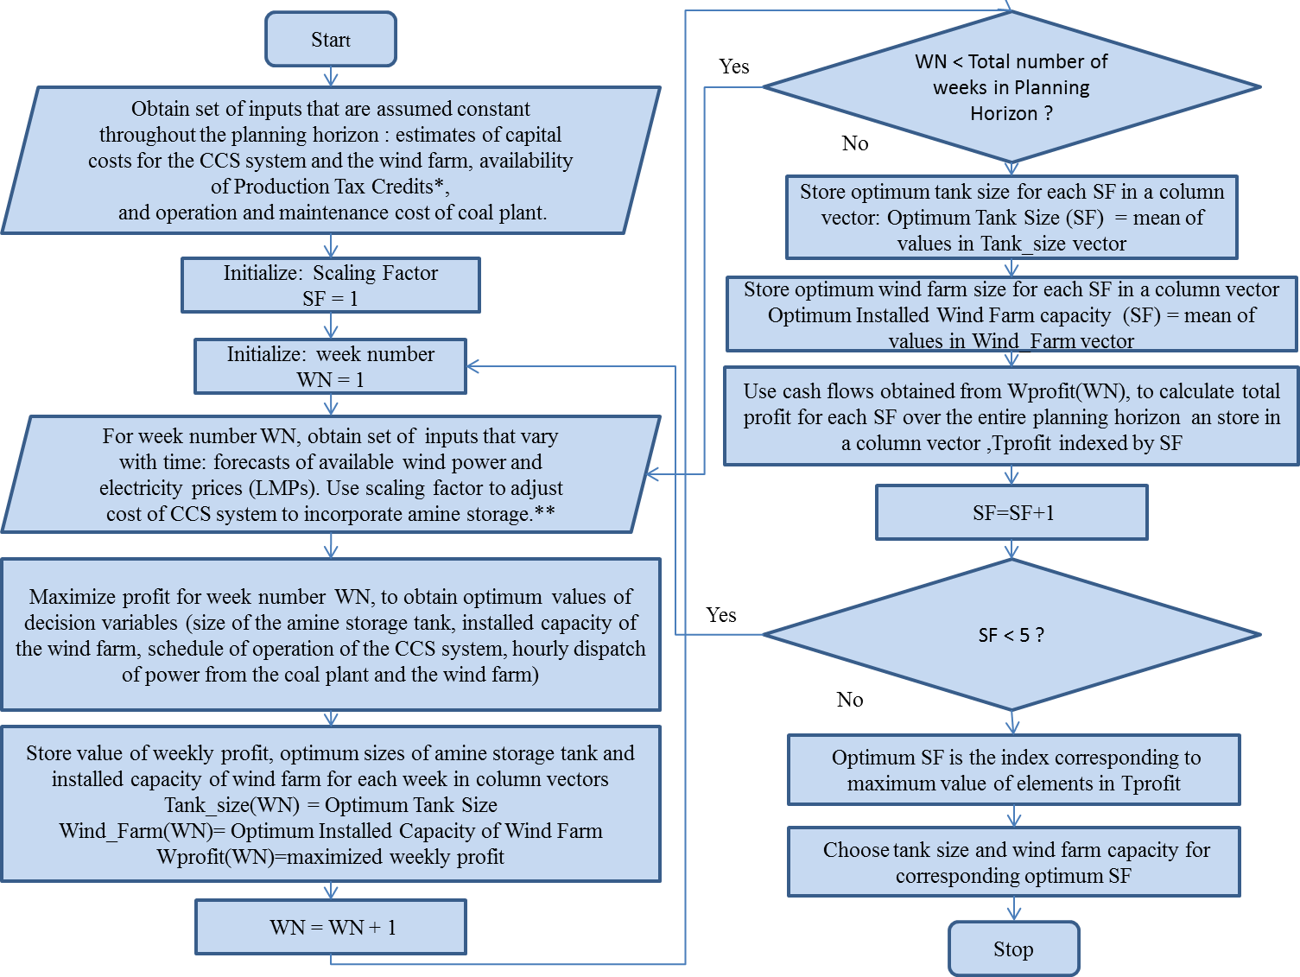

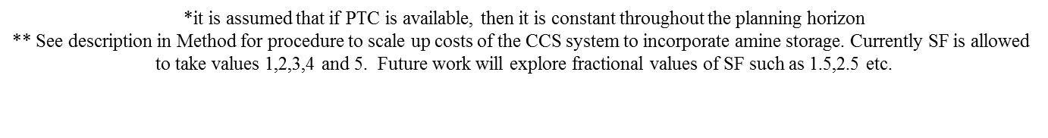
Figure 1: Flowchart to find optimum size of amine storage tank and optimum installed capacity of wind farm

4. The model

4.1 Overview
Figure 2 provides a schematic diagram of the set of outputs and required inputs, for running the optimization model. The set of constraints for optimization have been listed under section 4.2. For the analysis done in this paper, it is assumed that perfect forecasts of electricity prices, production tax credits, and wind power are available. While a forecast of any of these three variables for an extended period into the future is inevitably surrounded by significant uncertainty this is a necessary assumption for a first order estimation of the viability of the system provided in this paper. (Future work will relax this assumption of perfect foresight)

Power grid operators must schedule resources with load following capability (i.e. units capable of ramping their power output up and down fast), and increase available spinning reserves to balance electricity demand and supply at all times. This need for load following capability is exacerbated with higher penetration of Variable Energy Sources (VER) such as solar and wind power [12, 13]. To reduce wind power integration costs, and make this resource behave more like any other baseload generation source, this paper considers cases in which no variations are allowed for hourly power output dispatched from the hybrid system.

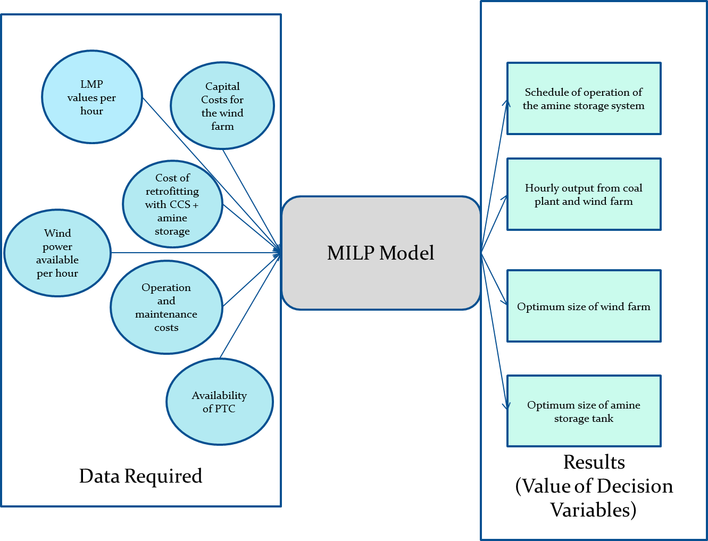

Figure 2: Schematic Diagram for optimization model

4.2 Problem Formulation

The decision variables for the optimization function are:

$O_{w,t}$ = The hourly dispatched wind power (MW)

$O_{c,t}$ = The hourly dispatched output from the coal plant (MW)

$X_{t}, Y_{t}, Z_{t}$ = Binary decision variables$(0→mode off, 1→mode on$), indicating whether the amine

storage system is in storage mode, regeneration mode or regular operation mode respectively

$O_{W}^{max}$ = The installed capacity of onsite wind farm (MW)

${ H}_{S}^{max}$ = The maximum number of hours for which the system can continuously store the CO₂ rich

amine solution (hours)

The optimization function chooses values of decision variables, so as to maximize profit.

Some parameters are defined here before writing down the objective function:
$LMP_{t}$ = Locational Marginal Price at hour t ($/MW) $\overline{E}$ = Energy Penalty per hour due to regeneration of saturated CO₂ rich amine solution (MW) $C_{fuel}$ = Fuel cost ($/MW)
SF = Overall scaling factor for CCS system to allow for amine storage
$CC_{wind}$ = Cost of installing the onsite wind farm per MW of installed capacity ($/MW) (Levelized over a
period of T hours by multiplying with a Fixed Charge Factor)
$CC_{amine storage}$ = Cost of installing the storage tank and cost of additional sorbent per hour of allowable
continuous operation in storage mode ($/hour) (Levelized over a period of T hours by
multiplying with a Fixed Charge Factor)
$PTC$ = Production Tax Credit per MWh of dispatched wind power ($/MWh)
$T$ = Hours in a week (hours).

The objective function $Ω$ represents the profit of the hybrid system for a given plant that has already incurred the expense of scaling up the CCS unit components by a known scaling factor (SF). Therefore the objective function includes the capital costs of the amine storage tank and wind farm, the fuel costs of the coal plant, and the revenues from selling electricity at the locational marginal price (LMP). It does not include the costs of scaling up the components of the CCS system in order to allow for amine storage, since SF is taken as an input parameter for each instance of the optimization problem and explored in an iterative process as explained in section 3.Since we assume the coal plant already exists, its capital costs are not included either. Similarly, the operation and maintenance costs of the coal plant (other than fuel) are not included because these are unaffected by the presence of the hybrid system and do not depend on the decision variables. Although not included in the objective function, both capital and O&M costs of the coal plant, and the costs of scaling-up the components of the capture plant are used to calculate the actual profit in the planning horizon, once the optimization is complete.

$$Ω=\sum_{t=1}^{T}{\left[\left\{O_{w,t}+O_{c,t}\right\}\left(LMP_{t})-(O_{c,t}*C_{fuel}\right)-Y_{t}\left\{\overline{E}\right\}\left(LMP_{t}\right)-Z_{t}\left\{(SF)\overline{E}\right\}\left(LMP_{t}\right)\right]-{CC_{amine storage}H}_{S}^{max}-{CC_{wind}O}_{W}^{max}}$$ (1)

Objective: $\max_{X_{t},Y_{t},Z_{t},O_{w,t},O_{c,t}^{storage},O_{W}^{max},H_{S}^{max}}{Ω}$

Subject to the following constraints:
1. The system should be running in at least one of the three modes at all time instants:
$X_{t}+Y_{t}+Z_{t}=1$ $, ∀ t∈\{1,…,T\}$ (2)
2. The tank should not overflow at any point of time:
$\sum_{i=1}^{t}{X_{i}-}(SF-1) \sum_{i=1}^{t}{Z_{i}-H_{s}^{max}≤0}, ∀ t∈\{1,…,T\}$ (3)
3. The unsaturated solution should not be regenerated at any instant of time.
$-\sum_{i=1}^{t}{X_{i}+}(SF-1 ) \sum_{i=1}^{t}{Z_{i}≤0 }, ∀ t∈\{1,…,T\}$ (4)
4. The installed capacity of wind farm should be greater or equal to the wind power dispatched by the hybrid system
at all instants of time.
${ O}_{w,t}-O_{w}^{max}≤0, ∀ t∈\left\{1,…,T\right\}$ (5)
5. The maximum limit on the hybrid units power output fluctuation ($ramp_{rate})$ should be maintained at all time
instants. For constant power output of the hybrid unit at all times, $ramp_{rate}$ is set to zero.
$-ramp_{rate}≤{(O_{c,t}+O}_{w,t})-(O_{c,t-1}+O_{w,t-1})≤ ramp_{rate}$ $∀ t∈\left\{2,…,T\right\}$ (6)
6. The wind power dispatched should be less than or equal to the available wind power forecast for each
hour ($O_{w,t}^{available})$.
${ O}_{w,t}≤O_{w,t}^{available}, ∀ t∈\left\{1,…,T\right\}$ (7)
7. $H_{S}^{max}$ should be less than the planning horizon in equivalent hours.
${ H}_{S}^{max}≤T$ (8)
8. The total power output of the hybrid unit at each hour should be at most equal to the nameplate capacity of the
coal unit ${(O}_{c}^{nameplate})$.
${ O}_{c,t}+O_{w,t}≤O_{c}^{nameplate}, ∀ t∈\{1, …, T\}$ (9)
9. The power dispatched from the coal unit should be at least as high as the minimum stable power output ($O_{c}^{min})$
requirements for safe operation of the coal plant.
${ -O}_{c,t}≤-O_{c}^{min}$ (10)
10. The coal plant output variations between consecutive hours should be within the ramp rate capabilities of the
coal plant (${rr}_{coal plant})$ :
${ -{rr}_{coal plant}≤O}_{c,t}-O_{c,t-1}≤{rr}_{coal plant}$ (11)
11. Non-negativity constraints for all decision variables

5. Obtaining input data

Some preliminary results are reported in section 6. The hybrid system for the results is modeled assuming a coal plant similar to the Powerton Plant in Illinois (a sub-critical coal plant with installed capacity 1785.6 MW). The plant characteristics were obtained from the eGrid database [14]. Capital costs of wind farms were obtained from [8]. Fuel costs were obtained by extrapolating data in [15]. Data for CCS energy penalty, capital costs and O&M costs of the coal plant were primarily obtained from the models built using IECM [4]. Similar to the analysis provided in the Supporting Information for [5], the cost of incorporating amine storage $(Cost_{amine})$ was calculated as follows:

$Cost_{amine}=$ Cost of additional amine solution + Cost of amine storage tank + Cost of scaling up
components of the CCS system to facilitate amine storage (12)

Cost of additional amine solution = Sorbent Circulation Rate (tons/hour)*$H_{S}^{max}$(hrs)*Cost of Sorbent ($/ton)
(13)
The cost of amine storage tank was obtained by performing linear regression analysis on carbon steel tank cost data available in [16]. The volume of the amine storage tank was considered to be the independent variable. The volume of amine storage tank is related to $H_{S}^{max}$ as:

Volume of amine storage tank (m³) = Density of sorbent (m³/ton) * Sorbent Circulation Rate (tons/hour) *
$H_{S}^{max}$(hours) (14)

Cost of scaling up components of the CCS system to facilitate amine storage
= SF *(Cost of the components of CCS responsible for regeneration and compression of a continuous operation
CCS) (15)

The amine sorbent considered in this case is an enhanced amine solution (the FG Plus solution). The capital costs of components of a continuous CCS system, sorbent circulation rate, cost of sorbent and density of sorbent are obtained from models built using [4]. For purposes of comparison, results were also obtained considering a 20% CCS energy penalty. The capital costs were levelized by using an annual Fixed Charge Factor of 0.1128, (this is the default value in [4] and is consistent with EIA estimates for retrofits for coal-fired power plants).

The Powerton plant is located close to a potential wind farm site (#4431) as indicated by the EWITS database [17]. The available wind power data from the EWITS database is used to simulate available wind power at the site using Markov Chain Monte Carlo method described in [18]. Similar to the analysis done in [8], a low quality cost multiplier of value 1.14 is used to scale up the capital cost of the wind farm, since the wind farm is co-located with the coal plant and therefore IEC-3 turbines are to be used to have access to good quality wind resources. Electricity prices (Locational Marginal Prices or LMPs) were obtained from the PJM website [19]. Information about coal plant ramp rate and minimum generation was obtained from [20].

6. Results

6.1 Assumptions for the base case
Results were obtained for a planning horizon of 15 years assuming this is the economic lifetime of the hybrid system. It is assumed the hybrid system acts as a source of baseload power at all time instants. No PTC is available for the base case scenario. CCS energy penalty is assumed to be (32%) as in the IECM model [4].

6.2 Optimum configuration
The optimization code is written in Matlab 2012b, and uses a Cplex solver. Results indicate that to maximize profits for the base case assumption, the wind farm should have 366.14 MW of installed capacity,${ H}_{S}^{max}$ should be 5 hours, and the relevant components of the CCS system should be doubled in size (i.e. scaled up by 100%). The configuration of the hybrid unit components (the installed capacity of the wind farm and the size of amine storage system) are based on the base case results.

6.3 Effect of LMP variations on weekly profit
The hybrid unit is designed to allow it to perform price arbitrage by exploiting the variability of electricity prices (LMPs) over time. Figure 3 illustrates how variability of LMP over time plays a major role in the amount of profit that the hybrid system makes. It depicts two weeks that had opposite extreme effects on profits of the hybrid system. The week labeled as "Best Case" is one when extreme LMP variations resulted in the maximum profits of the hybrid system across all weeks considered in the 15 year period. The week labeled "Worst Case" is when LMP values remained fairly stable over time, and led to highest loss across all weeks considered in the 15 year period.

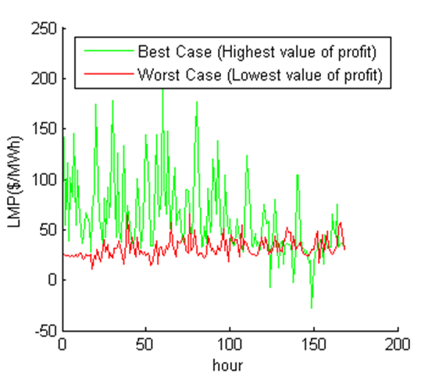

Figure 4: Effect of LMP variations on weekly Profit

To begin exploring the effects that CCS energy penalty and the allowed inter-hour power output variation have on profits, we consider two additional scenarios and their combinations: a) CCS energy penalty estimates of 20% (20% Energy Penalty Scenario), and b) the inter-hour power output variation of the hybrid unit could vary by up to 500 MW/hr (Varying Power Output Scenario).
The effect of this change on assumptions is explored by keeping the configuration of the hybrid system identical to the optimum configuration found under the base case assumptions (i.e. the values of the installed capacity of the wind farm: $O_{W}^{max}$, and the size of the amine storage system: $H_{S}^{max}$are as obtained from base case simulations), and finding the optimal operation schedule that maximizes profits.

Results for the 20% Energy Penalty Scenario and the Varying Power Output Scenario are explored by looking at the characteristics of the price regimes that make the system profitable. We define the mean hourly price differential, $PD_{hrly}^{mean}=mean of \left(LMP_{t}-LMP_{t-1}\right)$ for all weeks in the planning horizon of the given scenario, where the weekly profit is at least zero, and SD^{mean} = mean of the standard deviation of LMP values over 168 hours (24*7) for each week in the planning horizon, when the weekly profit is at least zero.

For the 32% (IECM) Energy Penalty Scenario combined with the Varying Power Output Scenario, the ${PD}_{hrly}^{mean}$ is 0.55 $/MW/hour and the SD^{mean} is 33.34$, as compared to the base case scenario, where ${PD}_{hrly}^{mean}$ is 0.65 $/MW/hour and the SD^{mean} is 36.32 $. This implies that when we allow the hour to hour output of the hybrid unit to vary rather than constrain it to stay constant at all times, the system can be profitable even when hourly prices do not fluctuate as much. This result is to be expected, since allowing greater flexibility of operation causes the system to rely less on price arbitrage for making profits.

The effect of lower estimates of CCS energy penalty (the 20% Energy Penalty Scenario) on weekly profits is not as straight forward. On one hand, we will incur a lower loss of revenue for durations when LMP values remain consistently high for time durations that are greater than $H_{S}^{max}$; on the other hand, when LMP values vary wildly on an inter-hourly basis, we are more likely to be at an advantage if the CCS energy penalty is comparatively high, so that we can sell very little power during low electricity price hours and use the rest for regeneration and compression, and make use of the empty storage tank during subsequent hours of high electricity prices. For the 20% Energy Penalty Scenario combined with the Constant Power Output Scenario, the ${PD}_{hrly}^{mean}$ is 0.63 $/MW/hour and the SD^{mean} is 35.71$, as compared to 20% Energy Penalty Scenario combined with the Varying Power Output Scenario, where ${PD}_{hrly}^{mean}$ is 0.49 $/MW/hour and the SD^{mean} is 31.26 $. For the current data-set we see that we do not gain any advantage by having higher energy penalty estimates for CCS, since the ${PD}_{hrly}^{mean}$and SD^{mean} is actually slightly lower for the 20% Energy Penalty Scenario compared to the 32% Energy Penalty Scenario (base case energy penalty), so chances of making a profit (for the current data-set) is slightly higher with lower energy penalty. An interesting question that could be pursued as part of future work, would be to identify the corresponding metrics of LMP variability, and difference of energy penalty estimates that would allow the system with higher energy penalty estimates to be at an advantage.

6.4 Identifying allowable range of capital costs
In this section, we look at results from the different scenarios, and note the mean excess revenue (Profit from optimization + default levelized cost of amine system or wind farm) available to the hybrid unit that could be used to cover costs of amine storage or the cost of installing the wind farm. For the base case scenario, with capital costs for wind held constant (equal to value in base case scenario), the mean excess revenue available to cover costs of the amine storage system is 136.22 * 10³ $/hour of amine storage/MW of installed capacity of coal plant, with a range of (3.6-534.6)* 10³ $/hour of amine storage/MW of installed capacity of coal plant. The current estimate using values in [4] is 279.32 * 10³ $/hour of amine storage/MW of installed capacity of coal plant. The mean value is higher for the different combinations of the 20% Energy Penalty Scenario and the Varying Power Output Scenario. The mean value is never equal or greater than the current estimates for any combination of scenarios for the current data set, implying that in general, greater electricity price variations need to be present for the hybrid unit to be able to make sufficient profit to cover the costs associated with amine storage.
The default estimate used in the base case, for capital costs of wind farms is 1,913$/kW (low estimate) and 2,120 $/kWh (high estimate) of installed capacity. Keeping the cost of amine storage system equal to its default value, we find that, on average, for the given data set, the hybrid makes enough excess revenue to cover the capital costs of the wind farm, for all combination of scenarios, including the base case. The mean excess revenue available for the base case scenario is 2,848 $/kW.

6.5 Effect of PTC on estimated LMP variations that allow the system costs and revenues to at least break even

We consider 4 different PTC scenarios: providing, 0 cents/kWh, 2 cents/kWh, 4 cents/kWh and 6 cents/kWh. The higher the PTC, the lower were the values of ${PD}_{hrly}^{mean}$and SD^{mean} , implying that as PTC increases, the lower is the dependence of the system profit on the variability of electricity prices. For example, for the base case scenario with 0 PTC, ${PD}_{hrly}^{mean}$= 0.63$/hour and SD^{mean} = 35.71 $ as compared to the base case scenario where a PTC of 6 cents/kWh was being provided in which ${PD}_{hrly}^{mean}$= 0.47$/hour and SD^{mean} = 30.11 $. Allowing inter-hour power output leads to still lower requirements of PD variations for the system expenses and revenues to at least break even.

7. Conclusion

This paper demonstrates the potential for coupling wind and coal plants retrofitted with CCS and amine storage as a viable source of electricity. Such a hybrid system not only provides a solution for reducing the CO₂ emissions from existing coal plants, but also deals with the problems associated with intermittency of wind-based electric power production and costs associated with integrating a new wind farm to the grid. Preliminary results reported here are encouraging, and indicate that operation of such a hybrid system could be profitable provided the site for the system is chosen carefully. It is to be noted that at present we have ignored the space requirements and cost of land acquisition for the wind farm. Further analysis needs to be performed in this regard.

Acknowledgements
Authors received financial support from the Climate and Energy Decision Making Center funded by the National Science Foundation (SES-0949710). We would also like to thank Dr. Sean McCoy for very valuable comments and suggestions.

References
1. Chung, T. S., Patino-Echeverri, D., and Johnson, T. L. “Expert Assessments of Retrofitting Coal-fired Power Plants with Carbon Dioxide Capture and Storage,” Energy Policy, June 2011. pp. 5609-5620
2. Rochelle, G. T. “Amine scrubbing for CO2 capture, perspective,” Science September 2009. pp. 1652-1654
3. Power Plant CCS Projects. http://sequestration.mit.edu/tools/projects/enel_1.html (accessed on 6th August 2012)
4. Carnegie Mellon University Center for Energy and Environmental Studies. IECM 8.0.2 public version, 2012 Integrated Control Model, Carbon Sequestration Edition. http://www.cmu.edu/epp/iecm/ (accessed on June 10th , 2010)
5. Patiño-Echeverri, D., and Hoppock, D. C. “Reducing Energy Penalty Costs of Post-Combustion CCS Systems with Amine-Storage,” Environmental Science & Technology, January 2012. pp. 1243-1252
6. Summary map for RPS Policies. http://www.dsireusa.org/documents/summarymaps/RPS_map.pdf . Accessed 13th January, 2013
7. New Wind Energy Resource Potential Estimates for the United States. http://www.nrel.gov/docs/fy11osti/50439.pdf . Accessed on 8th September, 2012
8. Hoppock, D. C., and Patiño-Echeverri, D., “Cost of Wind Energy: Comparing Distant Wind Resources in the Mid-Western United States,” Environmental Science & Technology, September 2010. pp. 8758-8765
9. Overview of Short-term energy outlook. http://www.eia.gov/forecasts/steo/ Accessed 13th January, 2013.
10. Litynski, J.T., Brown, B.M., Vikara, D.M., and Srivastava, R.D., “Carbon Capture and Sequestration: The U.S. Department of Energy’s R&D Efforts to Characterize Opportunities for Deep Geologic Storage of Carbon Dioxide in Offshore Resources,” Proceedings of the 2011 Offshore Technology Conference, Houston, Texas. 2-5th May, 2011.
11. Kang, A. K., Brandt. A.R., and Durlofsky, L. J, “Optimal Operation of an integrated energy system including fossil fuel power generation, CO₂ Capture and Wind,” Energy 36 (2011) pp. 6806-6820
12. Persaud, S., Fox, B., and Flynn, D. “Effects of Large Scale Wind Power on Total System Variability and Operation: Case Study of Northern Ireland,” Wind Engineering, Vol. 27, No. 1. 2003. pp. 3-20
13. Ortega-Vazquez, M.A., and Kirschen D.S., “Estimating the Spinning Reserve Requirements in Systems with Significant Wind Power Generation Penetration,” IEEE Transactions on Power Systems, Vol. 24, No. 1. February 2009. pp. 114-124.
14. eGRID. http://www.epa.gov/cleanenergy/energy-resources/egrid/index.html (accessed on 8th September, 2012)
15. Total Energy Supply, Disposition and Price Summary. AEO Table Browser. http://www.eia.gov/oiaf/aeo/tablebrowser/#release=AEO2012&subject=7-AEO2012&table=1-AEO2012&region=0-0&cases=ref2012-d020112c (accessed on 20th August, 2012)
16. Perry’s Chemical Engineering Handbook, 8th edition.
17. Obtaining the Eastern Wind Dataset. http://www.nrel.gov/wind/integrationdatasets/eastern/data.html (accessed on 19th August, 2012)
18. Papaefthymiou, G., and Klӧckl, B. “MCMC for Wind Power Simulation,” IEEE Transactions on Energy Conversion, Vol. 23, No. 1. March 2008. pp. 234-240.
19. Day-ahead LMP data. http://www.pjm.com/markets-and-operations/energy/day-ahead/lmpda.aspx
(accessed on 20th August, 2012)
20. Lindsay, J., and Dragoon, K., “Summary Report on Coal Plant Dynamic Performance Capability”, Renewable Northwest Project, August 16, 2010

Nicholas School of the Environment, Duke University. *rubenka.bandyopadhyay@duke.edu

